* 1. **RIP (ROUTING INFORMATION PROTOCOL)**
* It is a distance vector protocol based on hop count matrix. To find best path between source and destination network.(hop= how many stop, distance to the one router to destination is known as hop)
* Administrative distance (AD) value is 120.
* RIP routing work on the Network layer of the OSI model.
* RIP uses port number 520.
* RIP support maximum 15 hop count(0-15), means maximum 16 routers can be configured in RIP not more than.
* RIP is a class full routing protocol and its does not support VLSM.
* Bandwith utilization is very high as its broadcast its update in every 30 second.
* Slow convergence.(it means, the time any link goes down it should quickly choose an alternate route but in RIP it takes long time)
* RIP easy to configure.
* No Complexity and Less CPU utilization.

HOW RIP UPDATES **ITS ROUTING TABLE :**

**1) Update timer : 30 sec**

All the routers configured with RIP sends their update in every 30 sec.

**2) Invalid timer : 180 sec**

If any router got disconnected from the network. The neighbour router wait for 180 sec to hear the update. If it does not receive any update, it is going to mark that route as not reachable.

**3) Flush Timer : 240 sec**

If the router does not go up or not send the update till 240 sec= 4min the neighbour router is going on to completely remove that particular route from its routing table which is a very slow process

**RIP ROUTING PRACTICAL :**

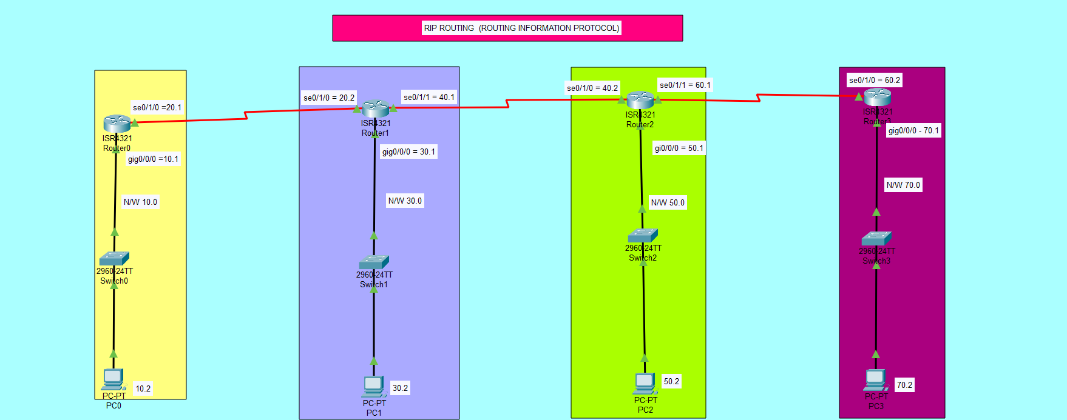

**Process :**

1. First take the 4 routers, 4 switches, 4 PC’s.
2. Connect all devices with the help of cable. But router to router connection first we drag and drop the back panel then router to router cable connect.
3. All PC’s configure IP’s and Gatways.

**COMMAND ON THE ROUTER 1 :**

Router>enable

Router#configure terminal

Router(config)#interface GigabitEthernet0/0/0

Router(config-if)#ip address 192.168.10.1 255.255.255.0

Router(config-if)#no shutdown

Router(config-if)#ex

Router(config)#interface Serial0/1/0

Router(config-if)#ip address 192.168.20.1 255.255.255.0

Router(config-if)#no shutdown

Router(config-if)#ex

**RIP ROUTING COMMAND**

Router(config)#router rip

Router(config-router)#network 192.168.10.0 in the network command assign the all network ip to coonected router

Router(config-router)#network 192.168.20.0

Router(config-router)#version 2

Router(config-router)#no auto summary

Router(config-router)#ex

**ROUTER 2**

Router>enable

Router#configure terminal

Router(config)#interface GigabitEthernet0/0/0

Router(config-if)#ip address 192.168.30.1 255.255.255.0

Router(config-if)#no shutdown

Router(config-if)#exit

Router(config)#interface Serial0/1/0

Router(config-if)#ip address 192.168.20.2 255.255.255.0

Router(config-if)#no shutdown

Router(config-if)#exit

Router(config)#interface Serial0/1/1

Router(config-if)#ip address 192.168.40.1 255.255.255.0

Router(config-if)#no shutdown

Router(config-if)#ex

**RIP ROUTING COMMAND**

Router(config)#router rip

Router(config-router)#network 192.168.20.0

Router(config-router)#network 192.168.30.0

Router(config-router)#network 192.168.40.0

Router(config-router)#version 2

Router(config-router)#no auto summary

Router(config-router)#ex

**ROUTER 3**

Router>enable

Router#configure terminal

Router(config)#interface GigabitEthernet0/0/0

Router(config-if)#ip address 192.168.50.1 255.255.255.0

Router(config-if)#no shutdown

Router(config-if)#exit

Router(config)#interface Serial0/1/0

Router(config-if)#ip address 192.168.40.2 255.255.255.0

Router(config-if)#no shutdown

Router(config-if)#exit

Router(config)#interface Serial0/1/1

Router(config-if)#ip address 192.168.60.1 255.255.255.0

Router(config-if)#no shutdown

Router(config-if)#ex

**RIP ROUTING COMMAND**

Router(config)#router rip

Router(config-router)#network 192.168.40.0

Router(config-router)#network 192.168.50.0

Router(config-router)#network 192.168.60.0

Router(config-router)#version 2

Router(config-router)#no auto summary

Router(config-router)#ex

**ROUTER 4**

Router>enable

Router#configure terminal.

Router(config)#interface GigabitEthernet0/0/0

Router(config-if)#ip address 192.168.70.1 255.255.255.0

Router(config-if)#no shutdown

Router(config-if)#exit

Router(config)#interface Serial0/1/0

Router(config-if)#ip address 192.168.60.2 255.255.255.0

Router(config-if)#no shutdown

Router(config-if)#ex

**RIP ROUTING COMMAND**

Router(config)#router rip

Router(config-router)#network 192.168.60.0

Router(config-router)#network 192.168.70.0

Router(config-router)#version 2

Router(config-router)#no auto summary

Router(config-router)#ex

**When all the router configuration done then check the all PC’s ping successfully.**